Bring the entire family to explore Pendleton:
- The Round-Up and Happy Canyon Hall of Fame
- The Heritage Station Museum
- The Pendleton Woolen Mills
- Pendleton Underground Tours
- Pendleton Water Park
- Pendleton Skate City
- At Wildhorse enjoy Golf, Cinaplex, Tamastslikt Cultural Institute, Arcade

As a Patroller come for a learning experience and expand your patrol family.

Thursday the 11th
Get here early, sign in and relax in the hospitality room.

Friday the 12th
There will be a fun filled BBQ Dinner with activities and a landing and presentation from Life Flight at the RV park.

Saturday the 13th
Continue your patroller education with breakout sessions for all disciplines.
That evening enjoy the Auction, raffles, and the Awards Banquet.

Sunday the 14th
Attend the Division Business Meeting.

Register Now! Only $55 until July 22nd

Convention Registration
Checks Payable to: PNWD 2016 Convention
Send to: PNWD 2016 Convention
c/o Dave Campbell
411 Fir, La Grande, OR 97850
Questions –Contact:
Convention Chair- Dave Campbell
habit@eoni.com 541-963-9602 (ask for Dave)

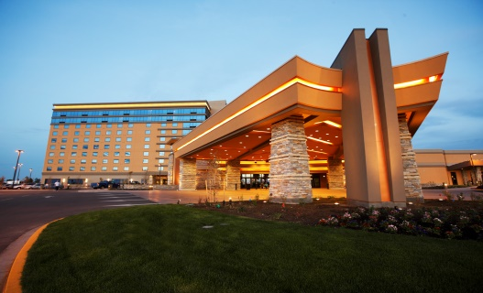
Hotel Reservations at Wildhorse Resort and Casino 46510 Wild Horse Blvd. Pendleton, OR 800-654-9453 http://wildhorseresort.com/

Call Wildhorse to book a room or RV space.
Use group name “PNWD Ski Patrol”
Reserve your room by July 22nd

Room Rates:
Courtyard (Ground-level/Outdoor Access Rooms): $84 (Thursday Rate)
$103/night (Weekend Rate)
Tower (Indoor): $103 (Thursday Rate)
$123/night (Weekend Rate)
RV Park within walking distance is
$65/night

